Name______________________ MATH 213 Test 1 Makeup

February 25, 2009

1. Consider the differential equation y” - 9y = 0. Find all constants r such that y = erx is a solution. Use this to write the general solution to the equation.
2. For the following direction field,
3. Identify (draw on graph) any equilibrium solutions and classify them as stable or unstable.
4. Draw the solution through x(0) = 1 on the graph.
5. Draw the phase portrait

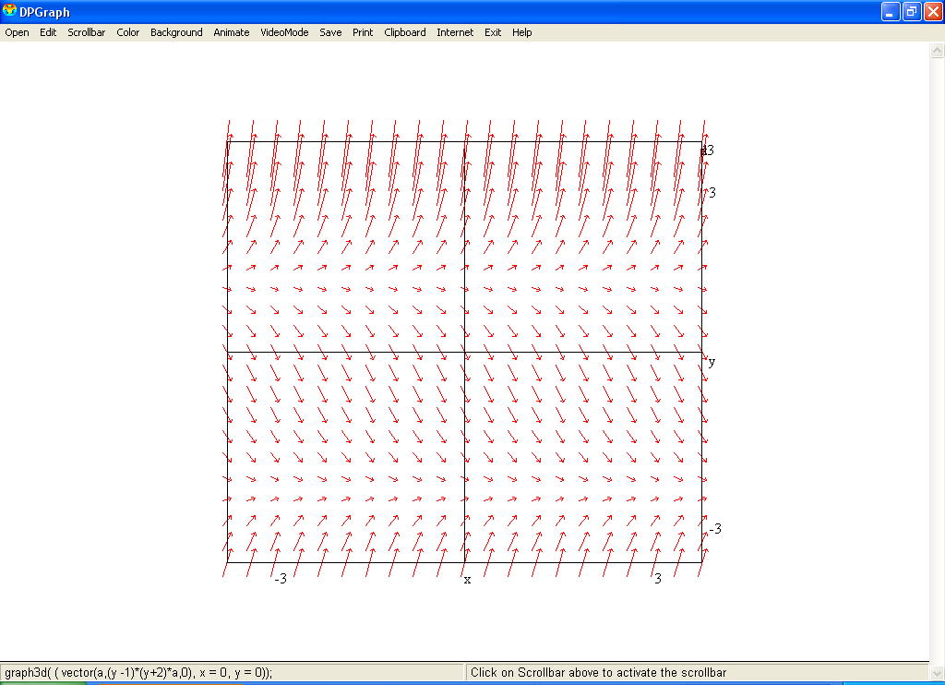

1. Solve the following DEs
2. (y2 - 4)dx = x dy
3. xy’ = 6x2 - 3yx, y(0) = 4
4. (3x2y2 + cos x cos y)dx + (2x3y – sinx sin y + 7)dy = 0
5. (xy + y2)dx – x2 dy = 0
6. y’/y = (xy3 - 1)
7. y’+ xy – 1 = 0
8. I am investing an initial amount of A0 in a money market fund that pays 4% compounded continuously
9. Determine a differential equation for A(t), the amount of money I will have at time t.
10. Modify your equation to include withdrawals at the rate of $500 per year.
11. Discuss the behaviour of my money over time. Does it depend on A0?
12. Explain/interpret the following equation from Dr. Kadera’s morning talk

ri’ = α(ri – mi)

**Points per question**

|  |  |  |  |  |  |
| --- | --- | --- | --- | --- | --- |
| 1 | 2 | 3 | 4 | 5 | Sum |
| 8 | 10 | 72 | 8 | 5 | 103 |