CS 385 Chapter 4 Fall 2006

13
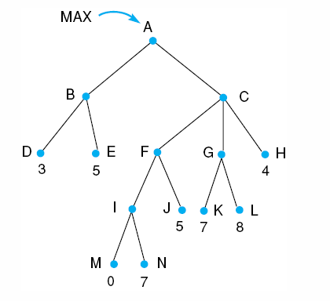
MIN

MAX

MIN

0
5
8
4
3
4
14. Red line indicates pruning. Left to right alpha-beta:

MIN

MAX

MIN

MIN on left-most deepest subtree (3,5) to get α at A = 3.
From next left-most deepest subtree (0,7), MIN of 0, prune.
F is now 5 and β at C = 5.
Subtree (7,8) is MAX, so with 7, 8 is β pruned.
Seeing the right-most 4, β at C = 4, and α at A = 4, the final backed up value.
(alpha is associated with max nodes and can never decrease, beta is associated with min nodes and can never increase)

Right-to-left alpha-beta:
MIN

MAX

MIN

Starting at the right-most deepest subtree, 4 gives β of C = 4.
Seeing 8 in subtree (7,8), 7 is β-pruned.
Seeing 5 next the entire subtree (7,8) is β-pruned.
A takes on the α value of 4.
5 and then 3 are examined (MIN) in the left-most subtree. The final value of A = 4.

17. You need some nodes known to be true and heuristic values assigned to the paths.

* Elements of open are combinations that will prove a goal.
E.g. (B,E) and D are generated by evaluating A.
* The heuristic value of a combination is the sum of its parts.
* When you evaluate a combination, expand the smallest part first.
* When a combination has the same value as a single, select the single.
* When two combinations have the same value, select the one with the fewest components.

Step | Eval | Open | Closed
1 |  | [A1] | []
2 | A | [D3, (BE)4} | [A]
3 | D | [(BE)4, C5, F5] | [D, A]
4 | B | [((EG)E)3, C5, F5] simplifies to  [(GE)3, C5, F5] | [B, D, A]
5 | G | [E2, C5, F5] | [G, B, D, A]
6 | E | [(GI)2, C5, F5] simplifies to  [11, C5, F5] | [E, G, B, D, A]

