Assignment for 3 Fall 2006
1, 4, 5, 7, 8, 10-13.Additions:
5: redo for breadt h-first and depth-first search
10: replace predicate #4 by warm(saturday). Recreate the graph in Figure 3.25 and find
location(fred,Z) by data-driven search.
13: parse a sample sentence using these new rules using both data driven and goal driven search.
------------------------------------------------------------------------------------------------------------------

1. 0 or 2 nodes are of degree 1, the rest are of degree 2.

4. B and all cross arcs (AC,AE, BD,BE, CD) are 2
4 4
A C
1 4
D 4 E
Path: A-D-B-E-C-A (13) versus A-C-D-B-E-A (10)
One possible heuristic: explore both the nearest and next nearest neighbors at each stage. This reduces the search space but protects from being too shortsighted.

5. CS SL NSL DE
A [A] [A] [ ]
B [BA] [BCDA] [ ]
E [EBA] [EFGBCDA] [ ]
J [JEBA] [JKLEFGBCDA] [ ]
K [KEBA] [KLEFGBCDA] [J]
L [LEBA] [LEFGBCDA] [KJ]
F [FBA] [FGBCDA] [ELKJ]
G [GBA] [GBCDA] [FELKJ]
M [MGBA] [MNHGBCDA] [FELKJ]
N [NGBA] [NHGBCDA] [MFELKJ]
H [HGBA] [HGBCDA] [NMFELKJ]
O [OHGBA] [OPHGBCDA] [NMFELKJ]
P [PHGBA] [MNHGBCDA] [ONMFELKJ]
C [CA] [CDA] [GHPONMFELKJ]
D [DA] [DA] [CGHPONMFELKJ]
I [IDA] [IDA] [CGHPONMFELKJ]
R [RIDA] [RIDA] [CGHPONMFELKJ]
- [] [] [ADIRCGHPONMFELKJ]

Do the same problem for breadth-first and depth-first:

DFS
X open closed
[A] [ ]
A [BCD] [A]
B [EFGCD] [BA]
E [JKLFGCD] [EBA]
J [KLFGCD] [JEBA]
K [LFGCD] [KJEBA]
L [FGCD] [LKJEBA]
F [GCD] [FKLJEBA]
G [MNHCD] [GFKLJEBA]
M [NHCD] [MGFKLJEBA]
N [HCD] [NMGFKLJEBA]
H [OPCD] [HNMGFKLJEBA]
O [PCD] [OH...]
P [CD] [POH...]
C [D] [CPOH...]
D [I] [DCPOH...]
I [R] [IDCPOH...]

BFS:
X open closed
[A] [ ]
A [BCD] [A]
B [CDEFG] [BA]
C [DEFG] [CBA]
D [EFGH] [DCBA]
E [FGHIJKL] [EDCBA]
F [GHIJKL] [FEDCBA]
G [HIJKLMN] [GFEDCBA]
[IJKLMNOP] [HGFEDCBA]
[JKLMNOPR] [IHGFEDCBA]
[KLMNOPR] [J IHGFEDCBA]
[LMNOPR] [KJIHGFEDCBA]
MNOPR] [MKJIHGFEDCBA]
[NOPR] [NMKJIHGFEDCBA]
[OPR] [ONMKJIHGFEDCBA]
[PR] [PONMKJIHGFEDCBA]
[R] [RPONMKJIHGFEDCBA\
[ ]

7a. data-driven - you have a specific set of conditions (data) from which to draw conclusions
(move towards a goal which is unknown)..
- goal driven from the common ancestor. You want to go from the same ancestor (goal) to you and your supposed cousin (data)
- data driven from me and from other person - you have no goal (common ancestor) to start with.
- goal driven - there are too many theorems to just start proving and hope it will find the one
you want.
- data driven - from submarine data to possible interpretations. We don't know which one to aim for.
f. data driven - the data for a single plant is more managable than backing up from the large
number of species (potential goals).

8. a. BFS because it may be an easy problem, quickly solved
b. DFS--you need to get to today's offspring and the path will not be short
c. not much difference, you have to get back 8 generations
d. BFS--you don't know how many steps
e. BFS--stop when you have an id
f. Don't know

10. Goal-driven:
location(X,Z)?
Try to match lhs of Rule 7:
gooddog(X)
Try Rule 6
Rule 1: (collie(fred)) and
Rule 5: trained(fred) give a binding {fred/X}
master(fred, Y)
Rule 2: master(fred, sam) give binding {sam/Y}
location(sam, Z) satisfied with {museum/Z}
Rule 7 satisfied with { fred/X, sam/Y, museum/Z }
location(fred, museum)

Data driven:
Rule 6 with collie(fred) and trained(fred) -> gooddog(fred)
Rule 9 with day(saturday) and ¬warm(saturday) -> location(sam,museum)
Rule 7 with gooddog(fred) and master(fred,sam) and location(sam,museum)
-> location(fred, museum)

** Replace predicate #4 by warm(saturday). Recreate the graph in Figure 3.25 and find
location(fred,Z) by data-driven search.

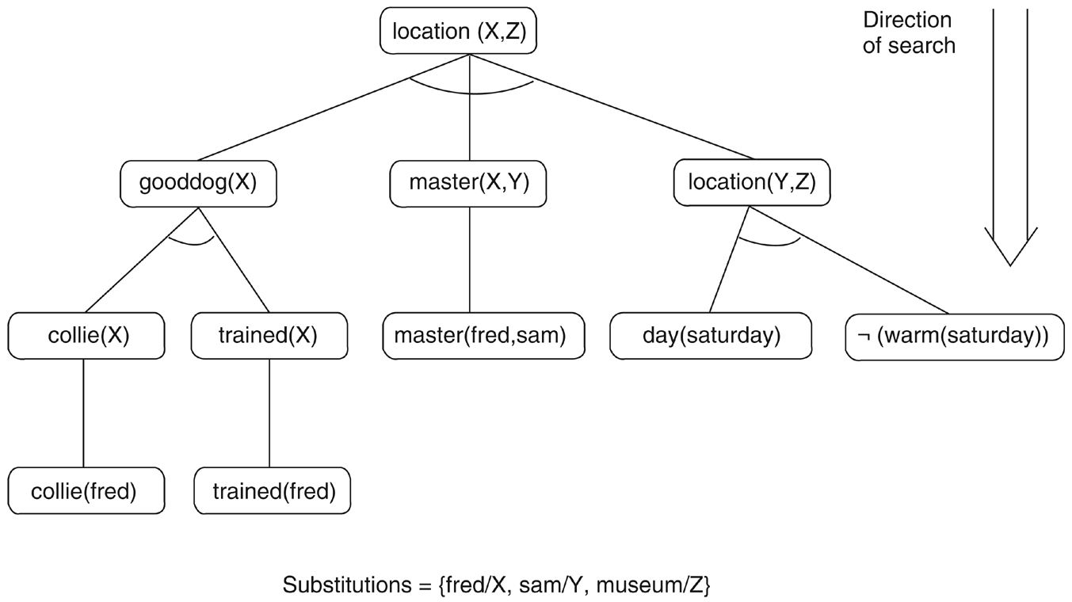
collie(fred) and trained(fred) -> gooddog(fred)
day(saturday) and warm(saturday) -> location(sam,park)
gooddog(fred) and master(fred,sam) and location(sam,park) -> location(fred, park)

12
9’ amount_saved(18000)
10’ earnings(25000, steady)
11’ dependents(4)

minincome(4) = 15000 + 4*4000 = 31000
minsavings(4) = 4*5000 = 20000

12’ 10’ and 11’ unify with lhs 7 and ¬greater(30000, minincome(4)) to produce income(inadequate)

13’ 9’ and 11’ unify with lhs of 5 and ¬greater(15000, minsavings(4)) to produce savings_account(inadequate)

13’ and 1 => investment(savings)

Best strategy: data driven,

13
3’ np ↔ adj n
3” np ↔ art adj n

5’ vp ↔ v avb
5” vp ↔ v np avb

12 adj ↔ lively
13 adj ↔ happy
14 adv ↔ quickly
15 adv ↔ slowly

The new parse tree:

np vp
∪ ∪ ∪ ∪

n art n art adj n v v np v np adv
...
13* parse a sample sentence using these new rules using both data driven and goal driven search.
Data driven:
the happy man bites the lively dog slowly
art happy man bites the lively dog slowly rule 7
art happy man bites art lively dog slowly rule 7
art happy n bites art lively dog slowly rule 8
art happy n bites art lively n slowly rule 8
art happy n v art lively n slowly rule 11
art happy n v art adj n slowly rule 12
art adj n v art adj n slowly rule 13
np v art adj n slowly rule 3” note, at this point one might replace np v by
sentence, but it would fail (stuff left over) and the parser would have to backtrack to here.
np v np slowly rule 3’
np v art adj adv rule 15
np vp rule 1
sentence

Goal driven:
sentence
np vp
n vp (trying rule 2. The search will go down incorrect paths and have to backtrack.)
man vp //backtrack
dog vp // backtrack
art n vp
a n vp // backtrack
the n vp
the man vp // back track
...
art adj n vp
a adj n vp
the adj n vp
the lively n vp
the lively man vp
...
14.
16 pp ↔ p np
17 p ↔ on
18 p ↔ over
...

3''' np ↔ np pp //note possible recursion
5''' vp ↔ v pp

15.
1'' sentence ↔ sentence conj sentence

19 conj ↔ and
20 conj ↔ or
...

