Chapter 5 Solutions

5.2 Management activities such as proposal writing, project planning and personnel
selection require a set of skills including presentation and communication skills,
organizational skills and the ability to communicate with other project team
members.
Programming skills are distinct from these (indeed, it is a common
criticism of programmers that they lack human communication skills) so it does not
follow that good programmers can re-orient their abilities to be good managers.

Other points:programmers may not have enough scope to see beyond the programming aspect of a project

5.3 Project planning can only be based on available information. At the beginning of a
project, there are many uncertainties in the available information and some
information about the project and the product may not be available. As the project
develops, more and more information becomes available and uncertainties are
resolved. The project plan therefore must be reviewed and updated regularly to reflect
this changing information environment.

5.6
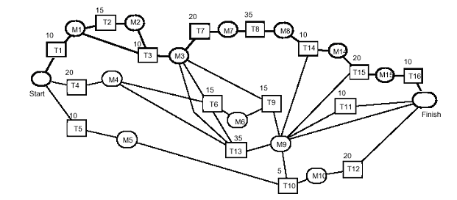

Or, using Microsoft Project:

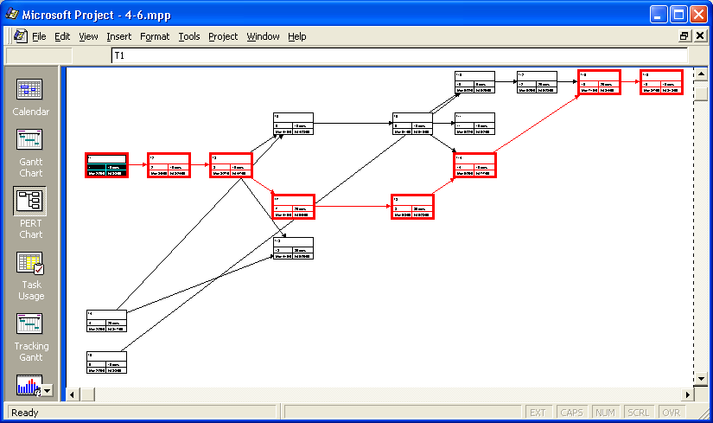
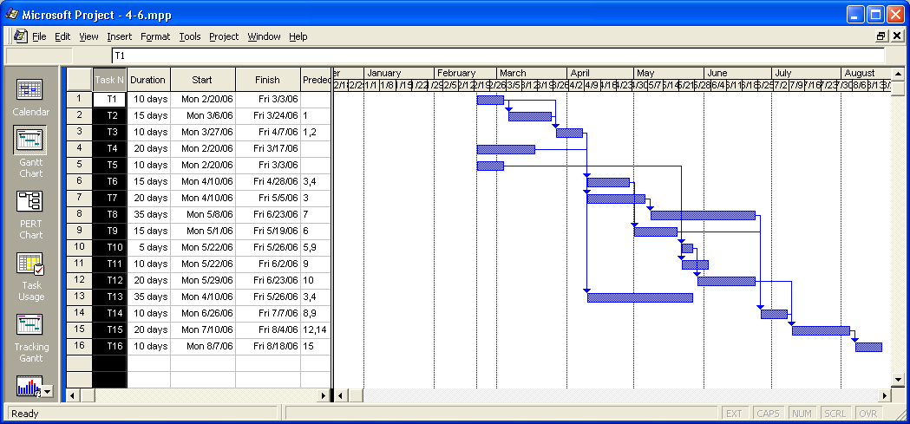

5.9
- Technology: new versions of products used in the project become available
- People: the people you hire aren't as able or as well-motivated as you had thought.
- Organizational: the organization is not mature enough to support the project
- Tools: They don't work as expected
- Requirements: they haven't been completely specified
- Estimation: the time required for subcontracted work is underestimated.
- Funding: not adequate
- Sabotage by competitor
- Act of God (tornado, power outage, fire..)
- Virus corrupts support environment

5.12 In a heartbeat. I am a better manager than programmer.

