Chapter 14 Homework

Subsystem: Weather Balloon
A context diagram or description (what does it interface with):

- Use cases
- One use case description
System | Weather Balloon
Use-case | Read
Actors | Weather Balloon, Weather Data Collection System
Data | The weather balloon queries each instrument (thermometer (temperature), barometer (pressure), hygrometer (humidity)) every 5 minutes and records each reading. Every 30-minute interval the collected data for that period is averaged for each category and a maximum and minimum value for that 30-minute period is recorded.
Stimulus | The weather data collection system sends a radio transmission to the weather balloon for launch
Response | The weather balloon begins reading data
Comments | The collected data is sent via radio transmission when transmission is requested from the weather data collection system
- An architecture for the subsystem (slide 17)
- Objects

Weather Balloon
Identifier
lauchBalloon()
calibrate(instrument)
test(instrument)
readData()
transmitData()
landBalloon()

BalloonData
Temperatures
Pressure
humidity
Read()
Average()

Thermometer
Temperature
Test()
Calibrate()
Barometer
Pressure
Test()
Calibrate()
Hygrometer
Humidity
Test()
Calibrate()

- Subsystem architecture (slide 17) redrawn with objects in it (slide 25)
- A sequence model indicating the interactions between your objects (slide 27) for one of the use cases

- The interfaces for your subsystem (slide 31)

interface WeatherBalloon
{
public void WeatherBalloon();
public void Launch()
public void Land()
public void calibrate(instrument x)
public void test(instrument x)
public void readData()
public void transmitData()
public void timer()
}

Weather mapping system – Map subsystem (Shea):

Map subsystem context:
Use cases for the map subsystem:

Use-case description:

System:
Map
Use-case:
Generate map image
Actors:
Weather data display system, Map
Data:
The Map system sends an image requested back over a network. The image is re-composited upon every request to the map manager, based on the map ID and size specified.
Stimulus:
A request is sent to the map manager over a network connection specifying a specific map ID and image size.
Response:
A response in the format of an image is returned.
Comments:
Maps are built from map images which have been organized into layers. Maps and map images may be invalidated if their information is out of date or an error is found. The map image is generated by compositing these layers according to specified parameters, then returning the resulting image.

Map architecture:

Map objects:

Map subsystems:

Generate map image UML sequence:

Map interface:

Interface Map{
public void Map();

public void createMap();
public void openMap(ID);
public void saveMap(ID);
public void deleteMap(ID);

public void invalidateMap(mapID);
public void invalidateMapImage(mapImageID);

public Image generateMapImage(ID, Size);
}

12.3 When we have the overall architecture design ready, and we can start to dip into each sub components. In each subcomponent, we need to design the structure, once we know the overall picture of the sub component; we are ready to think the different functionalities and variables of each object.
Data Archiving (Yan)
- Context Model
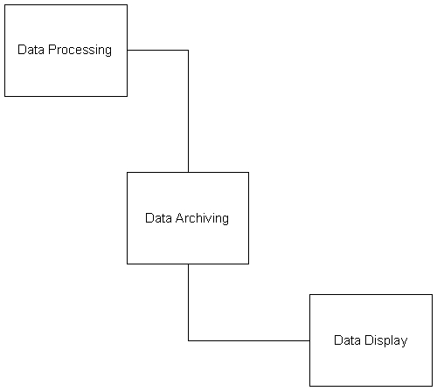

- Use Case
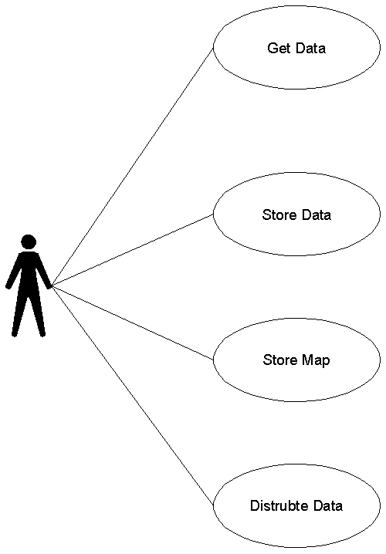

- One Use Case Description

System | Weather station
Use-case | Distribute
Actors | Weather data archiving system, Weather data processing system
Data | The weather data processing system sends a copy of integrated data to the weather data archiving system. The data sent are the collection of ground, air temperatures, air pressures, win speeds, the total rainfall, and the wind direction in average value, and the data was sampled in each 10 miles distance.
Stimulus | When the weather data archiving system gets the data, it will stores the data first, and then it will distribute the data into two different categories, which are map and data.
Response Comments | Even the weather data archiving system stores the map and data separately, but they are connected to each other by data storage.

- Weather data archiving architecture
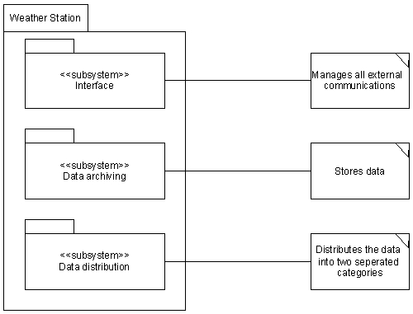

- Objects
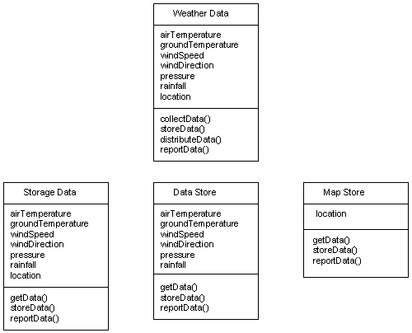

- Weather data archiving
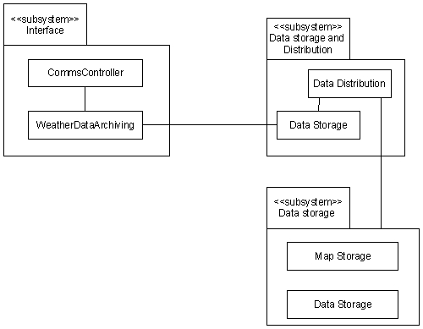

- Data storing sequence
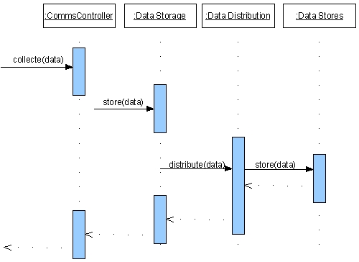

- Data Archiving Interface
interface DataArchiving {
public void DataArchiving();

public void getData();
public void getData(category i);

public void storeData(dataStorage);

public void distributeData();
public void distributeData(category i);

public void storeData();
public void storaData(category i);

}//DataArchiving

