Macromedia Flash 4: Only for Dummies
Zahra N. Taha
August 22, 2001
Prof. Shilepsky
Summer Internship

Outline

- Introduction:
  - What is Flash?
  - Flash’s initial developers
  - What is Flash used for
  - What are its capabilities
    - Text Animation
    - Scripting
    - Games
    - Movies
    - Interactivity
  - What interested me in this animation program
- The components of the Flash program:
  - The important components to a Flash program
    - Design consistency
      - Breaking the actions of each element into single parts
    - Layer setup
      - Guide layers
    - Symbols
    - Tweens
    - KeyFrames (blank)
  - Flash Language:
    - Flash like any program has its own language and names for its components.
  - The Stage, what it is:
    - Timeline
    - Toolbar
    - Scene
    - Movie
- How to get started with simple animation:
  - This is a simple text animation program to become familiar with Flash and what it can do…
  - After this step we’ll had random bells and whistles that will make the animation a little more exciting.
- Adding Elements to Flash:
  - Adding Music
  - Protecting your page (password)
- Conclusion:
  - What are the advantages of using Flash
  - What are the disadvantages
  - My thoughts about the program
    - Site that use Flash professionally

Web design and animation can be and many times is very complex. Great web pages may include DHTML, Flash, HTML, JavaScript, and/or XML; combined with great applications like Abobe Photoshop, Dreamweaver, Fireworks, and/or FreeHand; however, without communication to the viewer, the design is obsolete. Macromedia’s Flash animation application is web design’s newest and greatest program. It combines many of the capabilities that the above applications can provide, however, Flash cannot do everything. Combined with the best web design applications and a great developer, infinite design capabilities can be captured and amazing sites, created for either business or pleasure, can be implemented.
With the development of Flash 3, motion tweening allowed developers to create an interactive text and graphic animation. The development of Flash 4 and 5 introduced Macromedia’s own language called ActionScript, which made Flash a true multimedia and premiere design tool. Flash, a vector-based program designed by eight Macromedia developers, now allows for complete mobility within the design and interactivity, allowing designs of complex games, puzzles, and 3D graphical effects. According to motion graphics guru, Hillman Curtis, “the power of Macromedia Flash allows designers to combine moving visuals, sound and interactivity and deliver evocative content consistently to millions of people” (18. Flash Web Design).
The complexity of Flash can be overwhelming when delving into the world of motion graphics, therefore, in this paper, I will be discussing some key concepts to know about the look and feel of Flash 4 to help one get started with the process of becoming a Flash web designer.
Flash has its own language for many of its features. Before one is able to get familiar with the program, one needs to know the functions of the windows. When Flash is first opened the toolbar, timeline, and scene 1 are the windows showing, as shown and labeled below.
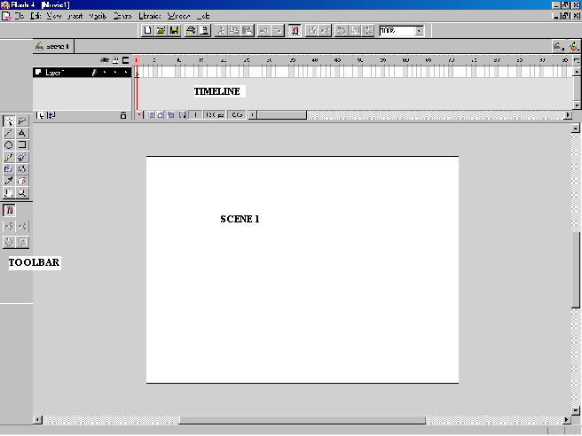
Flash is a layer-based program; therefore, every layer succeeds the first. One of the key elements to designing is organization. In reviewing Hillman Curtis’ book, Flash Web Design, creating multiple layers makes revising and organizing the Flash project easier. I find the easiest way to learn flash is by visual examples. I have done a couple of projects using Flash 4 and the first was text animation that is fairly simple. I will use this project as an example of the key components needed to develop in flash.
First Curtis, uses guide layers as a base layout. Guide layers are “to keep the movie action within set margins” and to work off of a center point (02:07).
To create a guide layer, right-click on the guide layer name and go to Properties and select the Layer Type: Guide and View Layer as Outline.
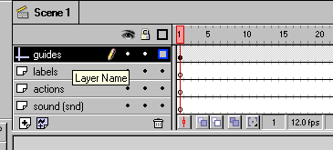
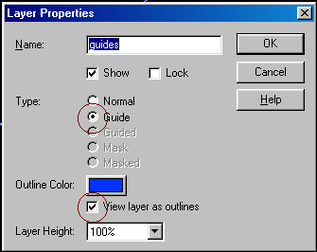
Next select the Layer Name: guide and draw the guide lines as shown below, using the Line tool from the drawing tool bar. Draw a line straight down the stage. 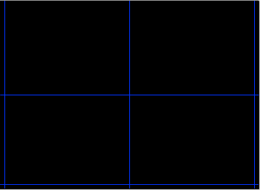
The next step is to create the text. The first step is to create a symbol. According Flash’s Lesson 2, a symbol “s a reusable image, animation, or button. Symbols help keep a file’s size low and make editing a movie easier. Symbols are also required to create sophisticated interactivity.”
To create a symbol choose Insert > New Symbol, label it with your first name.
Select the Text tool and choose a font, font size, and color.
Click onto the stage and type in your name. See example below.
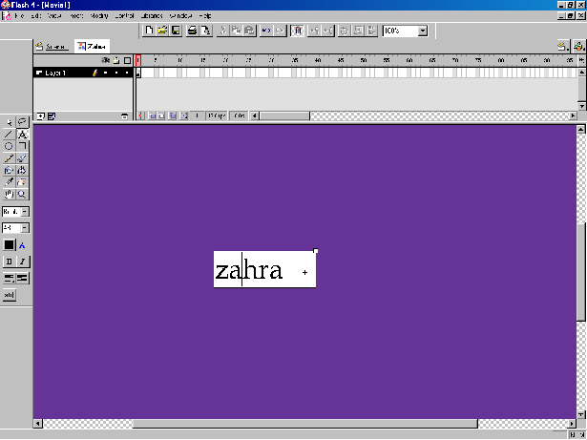
Align the text to the center by choosing Modify > Align 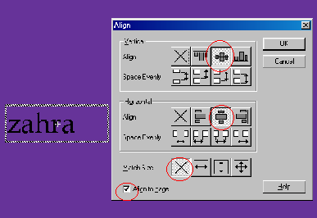
Now that the basic text is created, you need to create layers for each other letters, to control the animation of each letter. First, create a layer for each letter in the name you typed. Name these layers with the letters in your name (see below).
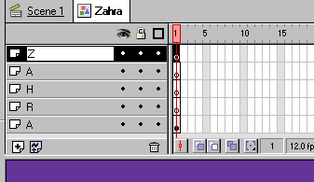
In your first layer (in my case “Z”), select “Zahra (your name)” and then choose
Modify > Break Apart. According to Curtis, the break-apart command is used to convert a text object into a series of shapes (02:13). The task is to make each letter-shape a symbol and layer.
Select the first letter of your name choose Ctrl-F8 to create a symbol and label it Letter “Z” (the first letter in your name). Note: A symbol cant have the same name. For
Then cut the letter using Ctrl-X and select the first Keyframe in the Layer Name of the letter. See example below. Note: the red frame selected is called a Keyframe.
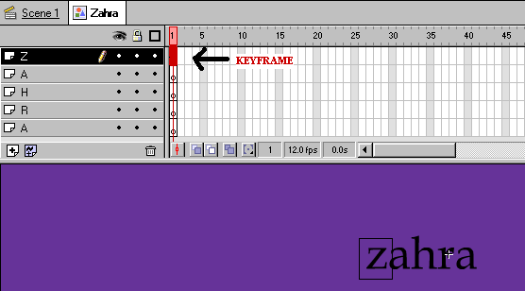
After selecting the Keyframe, choose Ctrl-Shift-V to place the letter in its original position.
Repeat these steps for each letter and Layer Name.
The next step in creating animation for text is to add frames and Tweens. In the 20th frame of the Timeline, select and drag down through all of the layers, choose Insert > Frame.
Now drag down the 10th layer of the Timeline and use F6 to create a Keyframe.
To create a Tween, select layers between the first and the tenth frame. Drag down and choose Insert > Create Motion Tween. (See example below).
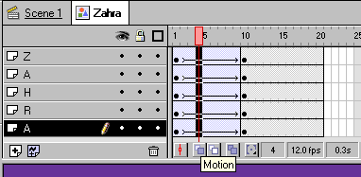
The above is what your Timeline should look like.
To fade and scale the text, in the first layer and first keyframe choose
Modify > Instance > Color Effect tab > Alpha
Change the Alpha in the first frame to 0%. Then choose Modify > Transform > Scale and Rotate and adjust both to 55%. This will make each letter disappear and rotate. Do this for each letter. In the final step stagger the frames for each layer (see next page).
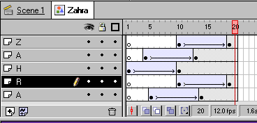
To bring everything all together, go to Scene 1 and add 30 frames.
(Need to add more)
I chose Flash to study because it is the latest multimedia web animation program on the market. Everyone is creating websites in Flash! I find web designing extremely exciting and Flash is the best program to learn, but is by no means the easiest. Once I became familiar with the program I continued to explore other design possibilities with Flash. To create extreme interactive sites, one needs to learn ActionScripting. ActionScripting will allow unlimited movement with text and picture graphics. It will allow you to create something as complex as games or create something as simple as a drop down menu. ActionScripting is definitely the key to a great website.
While overall I think Flash is a great program, it isn’t user friendly. If you’re not familiar with the program, Flash 4 Bible, Flash Web Design, www.flashkit.com, and www.flashplanet.com, are great resources to help you get started. The disadvantages of flash are that it is expensive. If you jump into Flash without a book or going through the Flash tutorials, you’re lost! Also, once you create and publish a Flash project if the site viewer does not have a Flash player, they can’t view the site and has to download the player, and then come back to the site. This process can be tedious. However, once the player is downloaded any Flash site can be seen. The advantages of a flash program are that it draws the viewer into the site. The graphic designs can be very intriguing and creates attention to the site. Also, the monetary rewards when creating a Flash website, for a living, can be tremendous. Flash web pages can cost from $75-$150 per second, depending on the difficulty of the site. It’s definitely been a fun, but difficult process developing Flash projects, learning Flash is an ongoing process. There are always new graphics to be developed using Flash and I’ve realized it takes more than a summer to become a Flash guru.

Bibliography
Curtis, H. Flash Web Design: The art of motion graphics. Indiana: New Riders, 2000.
Flash 4 and 5. Macromedia, Inc. 1996.
http://www.flashkit.com
http://www.flashplanet.com

