Experiences During My Internship with the Wells College Network Services Department
A CS 290 Internship
Neale Angelo Petrillo
9/3/2008

This paper is intended to summarize my experiences while interning with the Wells College Network Services Department over the 2008 summer.

Contents
Experiences during my Internship with the Wells Network Services Department 3
Appendix A 6
Hour Log 8
8/21/2008 8
8/22/2008 9
8/23/2008 10
8/24/2008 10
8/25/2008 10
8/26/2008 11
8/27/2008 12
8/28/2008 12
8/29/2008 13
8/30/2008 13
8/31/2008 13
9/1/2008 14

Experiences during my Internship with the Wells Network Services Department

During the 2008 summer I had the unique opportunity to intern as part of Wells College’s Network Services Department (hereafter known as “the department”). Over the course of this 80 hour internship I was able to learn and, more importantly, experience a variety of different jobs and duties that would have been hard to find in a classroom setting.
As a Network Services Intern my duties ranged from programming network equipment to mending broken hardware to configuring systems such that they properly interacted with the network. Perhaps the most important function I preformed was that of “field technician.” This particular duty allowed me to go forth around the Wells campus and mend various network ailments. These ranged from mundane cases of pushed in wall plates to the replacement of switches and configuration of client apparatus. None of these functions were a noteworthy tax on my mental capacities. That is to say, I learned very little new technical information; most of the time I possessed previous technical knowledge (my previous work study job had prepared me well) with the notable exception of the replacement switches for Zabriskie hall.
Before that experience I was never given the opportunity to program commercial grade switches for a production environment and, at the risk of reveling my true colors, I found it quite enjoyable. Again, it wasn’t much of a challenge (navigating a simple command line rarely poses a significant hurtle) but the idea of preparing a device for deployment into the real world was something surprisingly fun. Unfortunately, the hardware failed to function properly (through what the department has decided was no fault of my own) and was subsequently removed. Nevertheless, it was a memorable experience.
As previously stated, not much technical knowledge was gained during my internship; however, what I did take away was much more valuable: I had an opportunity to develop better interpersonal skills as well as have a perfect environment to better understand the necessity of time management. Learning how to do something is great; going out and applying your skills is great; dealing with clients along the way is not so great. I was, at the very least, taken aback by the people we had dealings with. That isn’t to say that the entire client base I had contact with was “bad,” rude, or were otherwise a chore to deal with, the experience was just not what I had been expecting.
I won’t go so far as to say that I had been anticipating a hero’s welcome (although, on more than one occasion I will admit to charging in and assuming a victor’s stance) but I had in possession a romantic notion of the plumber of yesteryear. Always on time with a smile and every conservable tool, our valiant plumber was greeted at the door by thankful housewives who promptly served tea and cookies. Unfortunately, my house calls were often met with a general feeling of frustration on the part of the client. Apparently, people are only mildly irritated when their sinks break, but should their internet slow the deepest furies of Hell are unleashed. To be perfectly honest, I wouldn’t have wanted it any other way. Had I not had the experience of dealing with unpleasant people I don’t think my internship would have been as rewarding. You can’t learn anything from normal people.
It is important to note that not all of the clients I dealt with were uncooperative or frustrated; a good majority of people were very friendly and reasonable.
Another important skill I learned was time management. As I hope most inexperienced people do, I approached this job with the upmost enthusiasm and a high drive to achieve. This quickly faded as more and more tasks were delegated to me and the work load soon ended any dreams I had of addressing all the issues associated with the Wells network. Mind you, I wasn’t discouraged, just overtaken by a sense of reality. To that end, I endeavored to manage my time more effectively. Regrettably, I never developed a system such that it could be well described through written communication (I understand that a great market exists for such documents, I wouldn’t mind being a millionaire) but I can say that I “learned” a system by which I was able to prioritize various tasks and came to realize that sometimes you have to say no. I have no doubt that that particular skill will serve me more than any other thing I’ve learned thorough my academic and societal careers.
Being a network services intern wasn’t all mundane and repetitive work (fortunately); there were several special projects I had the privilege of working on towards the end of the internship. First and foremost, I was designated the task of writing an efficiency report wherein I would express my views on how to improve the services provided by the department and how to generally make things run better. In my mind this was no small honor and I took the task very seriously. For political reasons I feel it is best to shy away from exactly what the report contained and it has little bearing in regards to this document. What is important to state here is that I took the opportunity to look at myself and the department, study what we were doing, and step back and take the time to think logically about the various things we were doing. Far too often I feel as though people get caught up in problems and various day to day activates and never really take the time to think about better ways of doing something. So, this opportunity to step back and analyze myself was a very valuable and rewarding experience. Also, I sincerely hope that the suggestions I gave will help the department provide a better level of service to students, faculty, and staff.
Second in the special projects category was the testing of an injury management system for the Wells Athletics Department. Prior to this I had never had much experience with deployments of large database systems. While this particular piece of software is not particularly complicated it is different, and that’s what really matters.
As with all software (and especially web) systems simply following the setup instructions very rarely works the way you would hope. It was a real challenge trying to figure out the various idiosyncrasies between the setup guides and the actual setup process. Then, configuring the system to work with Windows Server 2003 was a nightmare all its own. One could spend a lifetime reviewing configuration files and still not have everything behave in the manner you want. Regardless of the obstacles I am happy to report that the injury tracking software has been successfully tested and only awaits documentation and a full scale deployment.
My experience with the Wells Network Services department has given me a glimpse into the world of network administration; it has given me the opportunity to experience the real life struggle of network technicians first hand. The internship provided me with an opportunity to advance my interpersonal, time management, and problem solving skills. I was given the opportunity to try my hand at all sorts of physical problems ranging from simple jack failures to major hardware failures. I was able to test software and had the privilege of developing ideas that will, hopefully, lead to greater department efficiency. I have no doubt that the skill set I acquired over the summer will aid me in whatever career I decide to peruse.

Appendix A
Included here are the images displayed in the accompanying poster display.

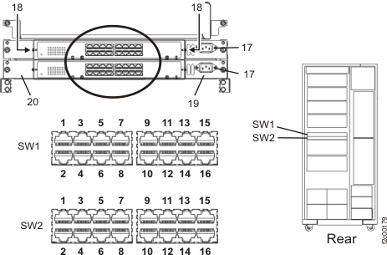
Figure 1
Figure 1 displays an image of the port layout of a standard Ethernet switch.

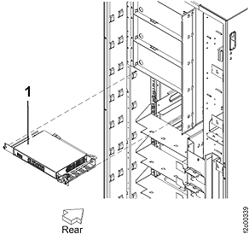
Figure 2
Figure 2 displays the procedure for adding a switch to a rack mount system.
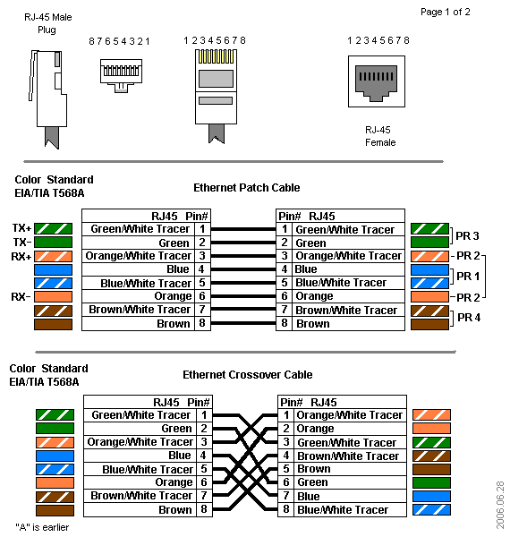
Figure 3
Figure 3 displays the proper pin arrangements for a standard 8P8C (often mislabeled as RJ45, as in the picture) terminals.

Hour Log
Included here is a complete listing of hours I worked as a Network Services Intern for Wells College.

8/21/2008

9:00
Met with Bill and discussed the day's plans.

9:15
Started trouble shooting Main Building. Checked jacks in 313; reported broken boxes to Buildings and Grounds in 429 and 229. Occupants of 416 and 427 were not available - will check back in the evening.

10:00
Started trouble shooting Weld. Occupant of 114 was not available - arrangements to be made.

10:15
Started trouble shooting Leach. Occupants of 104 and 105 were not available - will check back after lunch.

10:30
Started taking an inventory of Zabriskie data ports.

11:45
Went to lunch

12:30
Checked back with Leach 104; both data ports tested and working properly. Leach 105 needed help navigating the Blue Socket system.

13:15
Installed network jacks in Zabriskie 206 and 210.

15:00
Returned to office to plan next move.

15:30
Received call for replacement broadband modem. Dispatched to Shakleton Hardware to buy adapters for modem power cords.

16:00
Discussed plans for Friday.

16:30
Attempted to access the Pan server. Decided the physical server needed to be on the 10.3 network. Went to server room to transfer.

17:00
Break for dinner and returning athletes.

20:00
Checked back with Main 427. Had problems with Blue Socket system.

20:30
Checked back with Leach 104.

21:00
Researched various spy-ware removal tools for upcoming Connection Fest.

22:45
Ended day
Daily Total: ~10.00 hr Running Total: ~10.00 hr

8/22/2008

8:45
Started with morning meeting

9:30
Started updating IP address table

12:20
Finished IP address table and broke for lunch

13:10
Started programming switches for Main, the library, and Zubriski

14:30
After several switch failures we returned to the office to run more tests.

15:30
Decided that problems were probably due to bad fiber cards. We programmed one for the Main administrative network and proceeded to replace the doomed Cisco switch.

16:30
Returned to office to plan for the upcoming "connection fest"

17:00
Left for evening.
Daily Total: ~8.25 hr Running Total: ~18.25 hr

8/23/2008

17:00
Began getting together desired anti-spyware tools and help docs for connection fest.

19:00
Ended day.

Daily Total: ~2.00 hr Running Total: ~20.25 hr

8/24/2008

12:30
Started making signs for connection fest

13:15
Started connection fest

16:30
Finished connection fest, picked up signs.

Daily Total: ~5.00 hr Running Total: ~25.25 hr

8/25/2008

8:45
Started morning meeting.

9:30
Started installing network cables in Cleveland

10:30
Trouble-shooted internet connection problems in Stratton.

12:00
Lunch

12:30
Finished Stratton patching.

13:00
Visited Cleveland to discuss options for wiring problems.

13:30
Started house calls.

16:15
Returned to office. Started to pick up a little. Discussed plans for upcoming connection fest.

17:00
Retired for evening.

20:00
Researched open source library systems for possible use in the WRC library. Continued search for anti-spyware programs for Vista.

22:00
Ended day.
Daily Total: ~10 hr Running Total: ~35.25 hr

8/26/2008

8:45
Started morning meeting.

9:30
Started trouble shooting Zabriski.

12:30
Went to lunch.

13:00
Started setting up for connection fest.

16:00
Cleaned up connection fest.

16:30
Switched out new switches for old switches in a disparate attempt to restore internet functionality.

17:30
Ate dinner.

21:00
Worked on connection problems with Dodge residents.

22:00
Ended Day

Daily Total: ~8.75 hr Running Total: ~44.00 hr

8/27/2008

10:00
Started working on various help tickets.

12:00
Went to lunch.

13:00
Started programming access point.

14:30
Replaced nearly DSL modems in Barler in hopes to restore internet connectivity.

17:00
Ate dinner

18:00
Worked on ways to improve efficiency in the network services department

22:00
Started researching access point management system.

24:00
Went to bed.

Daily Total: ~10.50 hr Running Total: ~54.50 hr

8/28/2008

13:00
Continued researching access point management system.

13:30
Installed Cleveland AV center access point.

15:00
Started reclamation process for dead switches and fiber cards.

15:30
Went to class.

20:00
Started help tickets.

22:00
Worked on reports.

24:00
Went to bed.

Daily Total: ~6.50 hr Running Total: ~61.00 hr

8/29/2008

14:00
Checked unusual email addresses in the student and faculty email directories.

15:00
Repaired pushed in jack in Main

15:30
Worked on internet problem with Barler and Campbell.

16:30
Ate dinner.

18:00
Worked on efficiency report / researched injury management program for athletics department.

20:30
Ended day.

Daily Total: ~5.00 hr Running Total: ~66.00 hr

8/30/2008

12:00
Worked on efficiency report / worked on injury management program (made virtual machine, studied installation guide)

17:00
Ended day.

Daily Total: ~5:00 hr Running Total: ~71.00 hr

8/31/2008

12:00
Worked on injury management program for athletics department

17:00
Ended day.
Daily Total: ~5.00 hr Running Total: ~76.00 hr

9/1/2008

13:00
Started to set up Connection Fest

13:30
Started Connection Fest

16:30
Ended Connection Fest

18:00
Worked on injury management system for athletics department

20:00
Ended day.
Daily Total: ~5.50 hr Running Total: ~81.50

