CLASS 18 11/4/03

EXAM 2 IS A WEEK FROM THURSDAY
GO OVER QUIZ
GO OVER OLD HOMEWORK

We went over the quiz and discussed homework for most of the class so there is no new assignment.

The following was postponed to next class.

STATISTICAL INFERENCE

We learn methods for drawing conclusions about a population from sample data. This is called statistical inference.

Important—for the methods to be reliable you should be using properly generated random data. [e.g. SRS]

Two types of inference methods discussed—confidence intervals and tests of significance.

CONFIDENCE INTERVALS

Basic idea---- You have a population with a known (or approximated) standard deviation and you want to estimate the population mean μ. You could take a sample from the population and calculate X for the sample and use this number. This is called a point estimate. It is almost certain to be wrong and we have no knowledge about how likely it is to be a good estimate.

What can we do to make our estimate of the mean more useful?
Instead of giving a single answer, we can use knowledge of the interval probability model to come up with a better answer.
We will calculate an interval estimate—an interval that we expect contains the actual mean the population mean μ.

Requirements for this method. [later we will make the method more general]

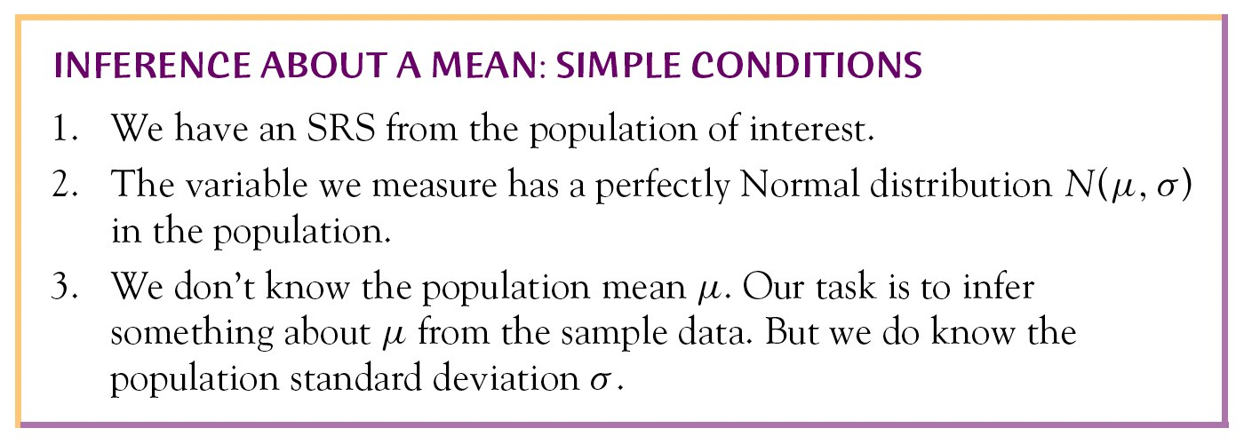

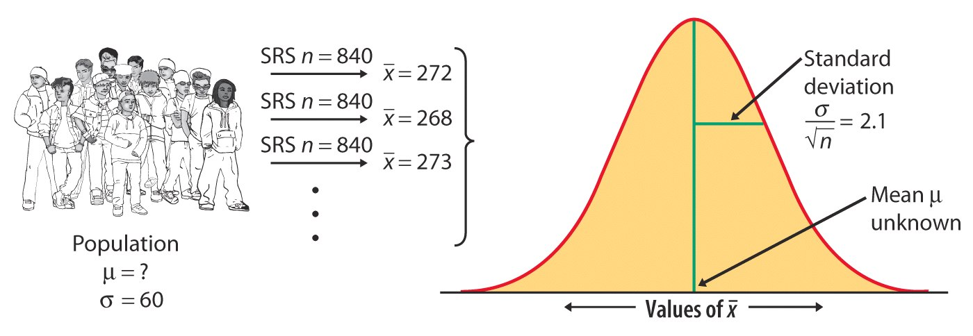

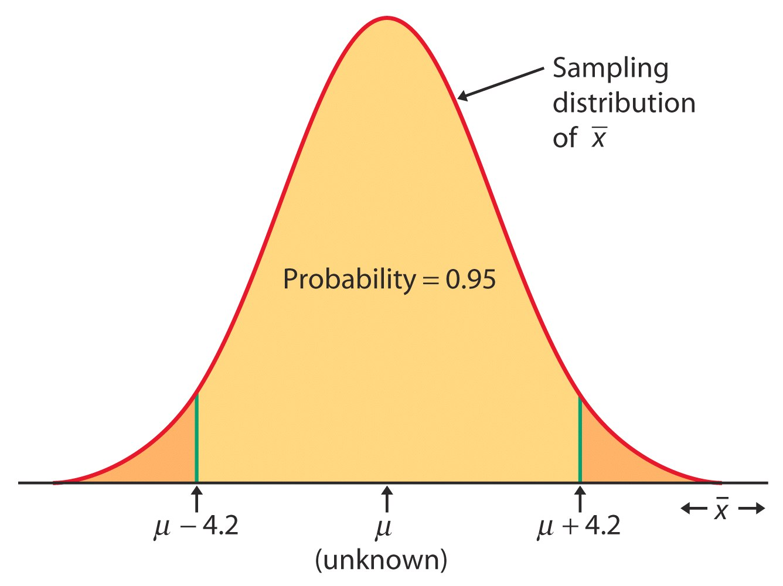

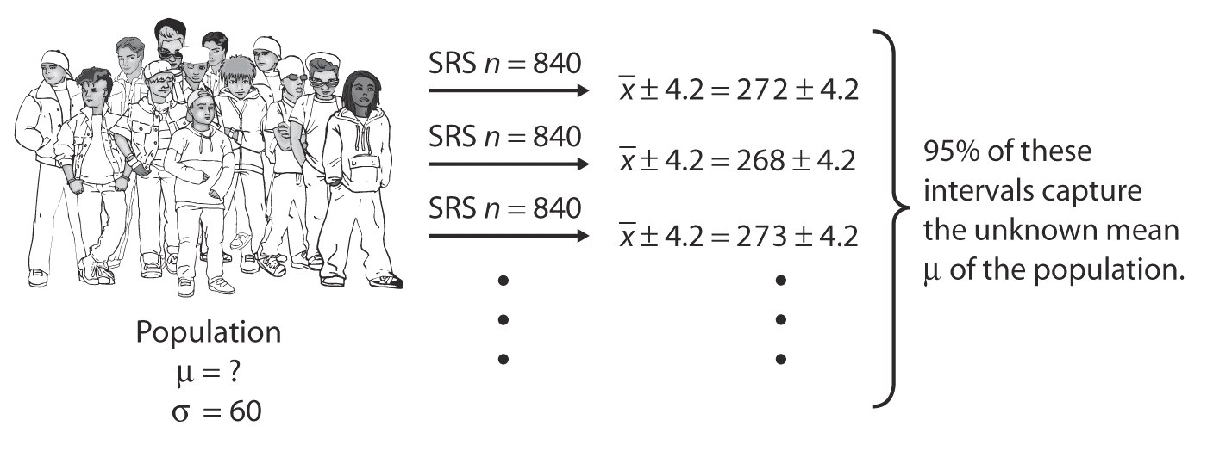
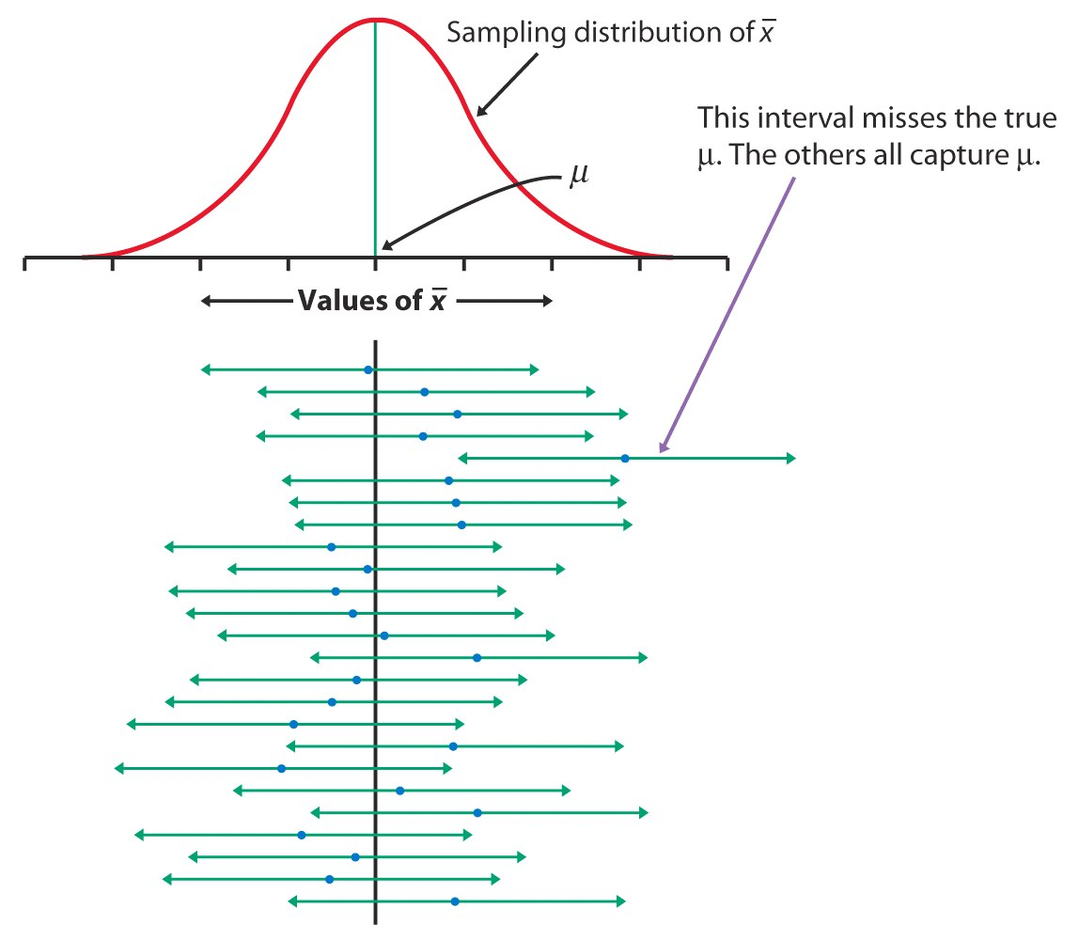

Suppose and IQ test has a standard deviation of 15. We would like to get an estimate of the mean IQ for this test 12-14 year olds in a given population. We take a SRS of 400 and give them the test and discover the mean of the sample is 92. [a point estimate]

Find an interval estimate and assign a confidence level to how good your methods are.

1. By the Central Limit Theorem we can assume the sampling distribution of samples of size 400 are approximately normal with the same mean as for all scores for 12-14 year olds in the whole population. The standard deviation however is approximately
σ/√ 400 = 15/20 = .75

Recall that the 95% of all observations are within 2 standard deviations of the mean for a normal distribution. (68-95-99.7 rule)

For our sampling distribution with unknown mean we would know that if we repeated our sampling many times 95% of the time the sample mean would be within two standard deviation of the actual mean. 2 times .75 = 1.5 92-1.5 = 90.5 92+1.5= 93.5

1.5 is call the margin of error

We create the interval 90.5-93.5 and use it as our interval.
What do we know about this estimate. It may or may not contain the population mean. We don’t know for sure!

However, if someone repeated our technique many times then about 95% of the time the population mean would be in the constructed interval! About 5% of the time it would not!

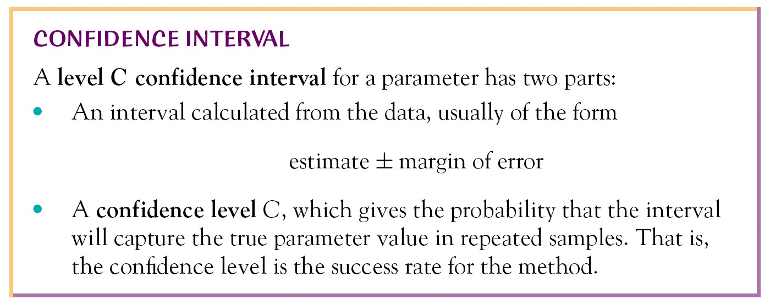

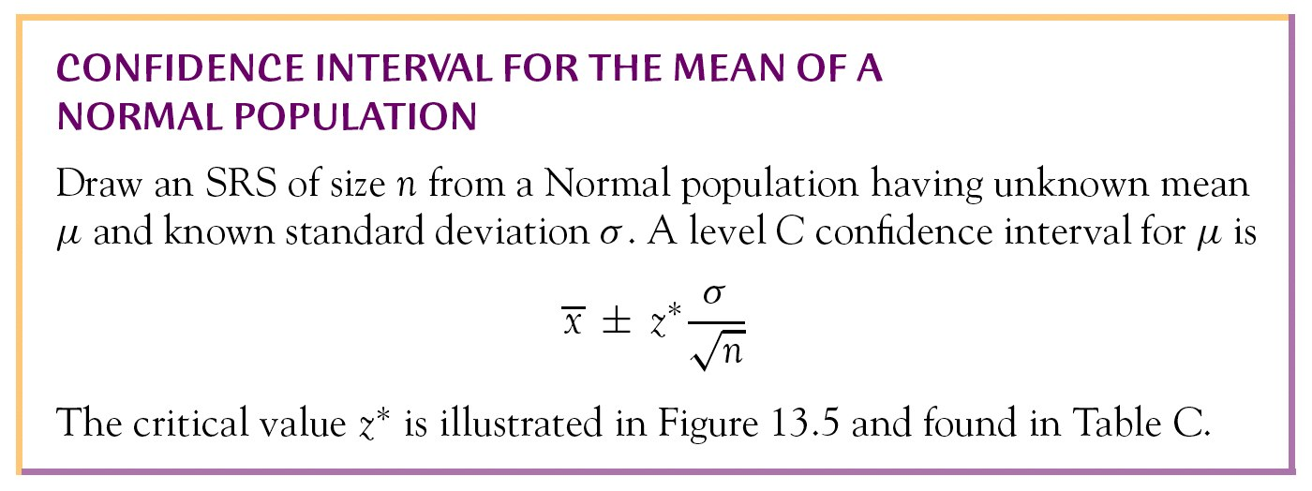

Go to TABLE C and explain how to fine z*.

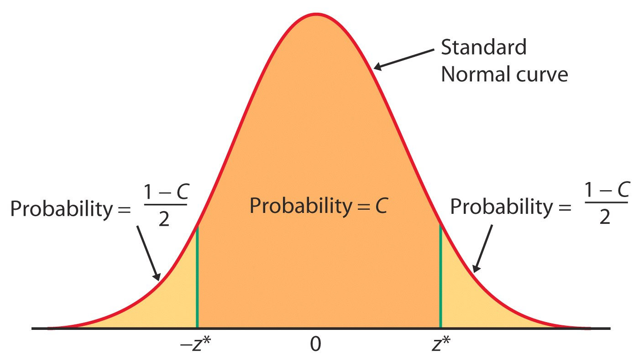

What happens to the confidence interval when you increase sample size? Explain from the formula.

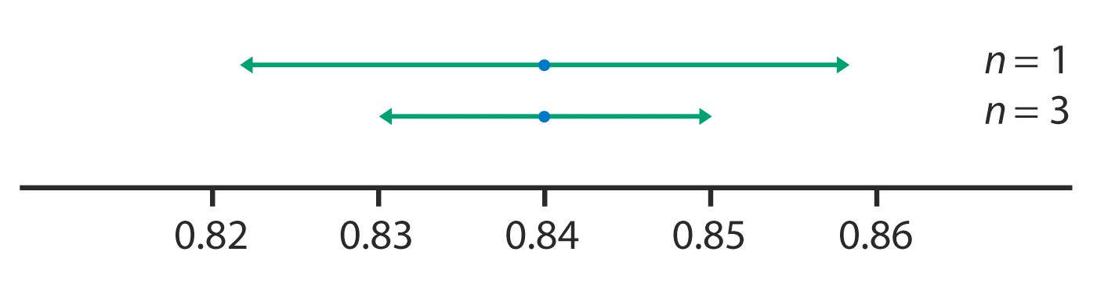

What happens to the confidence interval if you increase the confidence level? Explain from the formula.
`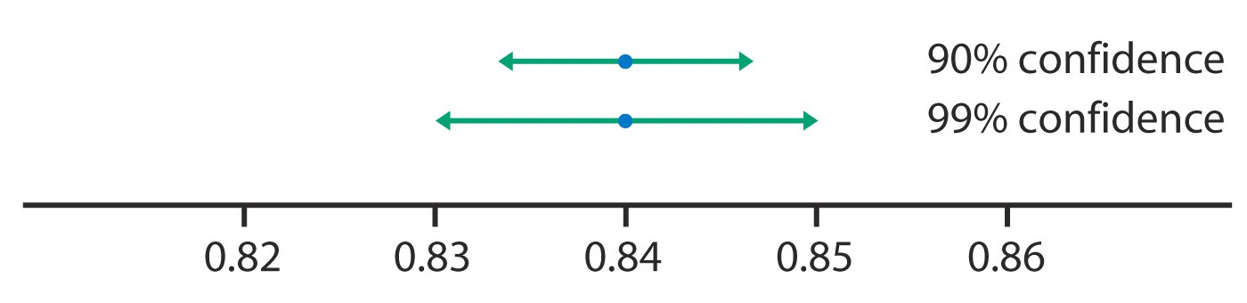

Things to remember:



